**COMSATS University Islamabad (CUI)**

**Project Proposal**

**for**

**Breath Disease Detection System**

(Valid title reflecting scope and objectives)

Version 1.0

***By***

**Ahmed Kamran CIIT/SP20-BSE-004/ISB**

**Daniyal Hassan CIIT/SP20-BSE-025/ISB**

***Supervisor*Mam Sadia Maqbool**

***Bachelor of Science in Computer Science (20xx-20xx)***

**Table of Contents**

Contents

Abstract 2

1. Introduction 2

2. Problem Statement 2

3. Problem Solution/Objectives of the Proposed System 2

3.1 Objectives 3

4. Related System Analysis/Literature Review 3

5. Vision Statement 3

6. Scope 4

7. Modules 4

7.1 Module 1: Admin Dashboard 4

7.2 Module 2: Customer Management 4

7.3 Module 3: Service Provider Management 5

7.4 Module 4: Voice Based Searching 5

7.5 Module 5: Semantic Review Analysis 5

7.6 Module 6: Chat feature for customer and service provider 5

7.7 Module 7: E-Commerce store Management 6

7.7.1 Submodule: Store Management 6

7.7.2 Submodule: Order Management 6

7.8 Module 8: Payment 6

8. System Limitations/Constraints 7

9. Data Gathering Approach 7

10. Tools and Technologies 7

11. Project Stakeholders and Roles 7

12. Module based Work Division 8

13. WBS and Gantt Chart 9

14. Mockups 11

15. References: 15

16. Plagiarism Report: 15

**Project Category:**

**A-** Mobile Application

**B**- Problem Solving and Artificial Intelligence\

**Abstract****:**

Tuberculosis (TB), COVID-19, and pneumonia are all respiratory illnesses that cause a significant threat to global health. Early and accurate detection of these diseases is crucial for prompt treatment and control of the spread. The proposed system presents a multi-disease detection application that uses computer vision and machine learning algorithms to diagnose TB, COVID-19, and pneumonia in chest X-rays. The application is trained on a large dataset of chest X-rays, annotated with ground truth labels, to identify the signs of these diseases in the images. The results of the proposed application show optimal results, sensitivity, and specificity in detecting TB, COVID-19, and pneumonia in chest X-rays, compared to traditional diagnostic methods. The proposed application has the potential to support healthcare professionals in making prompt and accurate diagnoses, improving patient outcomes and reducing the spread of these respiratory illnesses.

# Introduction:

The BreathEx is a web/smartphone application that will detect breath diseases including covid ,Pneumonia and COVID-19. Tuberculosis (TB), COVID-19, and pneumonia are respiratory diseases that causes significate threat to public health. Early detection of these diseases is crucial for treatment and control of their spread of disease in patient. However, traditional diagnostic methods are time-consuming, inaccurate, and limited in their reach. This presents a need for a more efficient and accessible method for diagnosing these diseases .To tackle this issue ,our system presents a TB, COVID-19, and pneumonia detection application that uses computer vision and machine learning algorithms to diagnose these diseases in chest X-rays. The application is designed to analyze chest X-rays to identify signs of TB, COVID-19, and pneumonia, and provide healthcare professionals with a prompt and diagnosis. The results of this application have the potential to significantly improve patient outcomes and reduce the spread of these diseases. The proposed application is an important step towards a more efficient and accessible diagnostic tool for TB, COVID-19, and pneumonia. It has the potential to support healthcare professionals in making prompt and accurate diagnoses and improving patient outcomes. Our proposed system provides a detailed summary of the proposed application and its potential impact on the field of respiratory disease diagnosis. This will save patients costs and time. Another problem is that it is very difficult for doctors to keep records of diseases.

# Problem Statement

Tuberculosis (TB), COVID-19, and pneumonia are respiratory diseases that cause a threat to public health, with millions of new cases being diagnosed each year. Early detection of these diseases is crucial for prompt treatment and control of their spread. However, traditional diagnostic methods, such as sputum microscopy and culture, can be time-consuming, inaccurate, and limited in their reach, particularly in resource-limited settings. Additionally, the COVID-19 pandemic has further highlighted the need for more efficient and accessible diagnostic tools .

The traditional diagnostic methods, such as sputum microscopy and culture, can be time-consuming and inaccurate, particularly in resource-limited settings. Traditional diagnostic methods can be limited in their reach, particularly in resource-limited settings.. The interpretation of chest X-rays can be subjective, and requires trained healthcare professionals. The COVID-19 pandemic has further highlighted the need for more efficient and accessible diagnostic tools. The proposed application aims to provide a tool that can support healthcare professionals in diagnosing TB, COVID-19, and pneumonia, and reducing the spread of these disease. Early detection of TB, COVID-19, and pneumonia is crucial for prompt treatment and control of their spread. The proposed application aims to improve patient outcomes by providing healthcare professionals with a prompt and accurate diagnosis.

# Problem Solution/Objectives of the Proposed System:- Chest X-rays are commonly used in the diagnosis of respiratory diseases, including TB, COVID-19, and pneumonia. However, the interpretation of chest X-rays can be subjective and requires trained healthcare professionals. There is a need for a more efficient and accessible method for diagnosing these diseases that can support healthcare professionals in making prompt and accurate diagnoses .This system presents a TB, COVID-19, and pneumonia detection application that uses computer vision and machine learning algorithms to diagnose these diseases in chest X-rays. The aim of the proposed application is to provide healthcare professionals with a prompt and accurate diagnosis, improve patient outcomes, and reduce the spread of these diseases. Patients have requested to build a system that could help to detect breath diseases sitting at their homes. Our proposed system will help patients detect disease at home using a smartphone. This will save time and cost for patients. Our proposed system will also recommend patients about medicine to take corresponding to each disease. Our proposal will also help patients consult a doctor through chats .Our proposed system will help doctors to keep records of patients' diseases and which person has which disease then based on that record he will diagnose the patient. Our proposed system will help patients to make an appointment with the doctor while sitting at their home with the help of Chabot using smartphones. This includes sending reports and receiving feedbacks from doctors.

## Objectives

*BO-1: Reduce the time of patient for consulting the doctor.*

*BO-2: Save time of doctor for diagnosing a disease.*

# Related System Analysis/Literature Review

Table 1 Related System Analysis with proposed project solution

|  |  |  |
| --- | --- | --- |
| **Application Name** | **Weakness** | **Proposed Project Solution** |
| Breath Hub | The system is 60% accurate | Our proposed solution will gave accuracy up . |
|  | The system doesn’t have the option to consult to doctor e.g. Chabot to send messages and one-on-one calls to book appointments. | Our proposed solution will have a Chabot that includes sending messages and calling a doctor to book appointments. |
| Sensors for detecting pulmonary diseases from exhaled breath | The system is not easy to use and complex to understand. | Our proposed solution is user friendly, easy to understand and easy to use. |
| Brain tumor detection system | This is another system which detect brain tumors | Our proposed system is used for detecting the lung related diseases |

# Vision Statement

***For*** *patients* ***who*** *are suffering from breath related diseases,* ***the*** *Breath disease detection system* ***is*** *an web-based and smartphone-enabled application* ***that*** *will accept patient request to detect breath disease like asthma, lung cancer, COPD (chronic obstructive pulmonary disease ), COVID-19 and in response system will show result of detected disease and recommend precautionary medicines.* ***Unlike*** *the current systems for detecting diseases patient who will use* ***our product*** *will not have to visit doctor for disease consultation which will save time and cost of booking appointment.*

# Scope

The application would be designed to analyze chest X-rays to detect signs of TB, COVID-19, and pneumonia. The application would use machine learning algorithms, such as deep learning and computer vision, to accurately diagnose the diseases based on the features identified in the X-rays. The application would be trained on a large dataset of chest X-rays, annotated with ground truth labels, to increase its accuracy in detecting the diseases. The application could be integrated with existing healthcare systems to support healthcare professionals in making prompt and accurate diagnoses. The application would have an intuitive user interface for healthcare professionals to easily access and use the system. The application would generate reports that provide information on the diagnosis, including visualizations of the X-rays and the results of the analysis. The application would be validated using appropriate metrics, such as sensitivity, specificity, and accuracy, to ensure its accuracy in detecting TB, COVID-19, and pneumonia. The application would be deployed on appropriate platforms, such as mobile devices and desktop computers, to make it accessible to healthcare professionals globally. First of all user(patient) enter the system by login into the system. The system will display list of all the diseases available in the system. After that user(patient) can select a disease to detect. Then system will display result of detection and display a report of disease with which user is suffering from. These reports will assist the doctors in proceeding the treatment of the patient. Then system will recommend medical suggestion to user for cure of disease for time being. User(patient) can also set alarms for taking medicine at specific time and days. The system can detect four major diseases which include covid 19 ,pneumonia . The system will detect Asthma with the help of sound detection any abnormality in sound will detect Asthma. Lung cancer is detected with the analysis on chest radiographs which can achieved through ML by gathering datasets of different patients. The system is also capable of detecting COVID by analyzing X-rays of patients through ML. The system will detect COPD by analyzing the crackling sound of patient through ML. The system will give optimal result.

# Module

***Module 1:- PATIENT Profile Management***

*FE-1:-This module will allow the patients to perform all the tasks related to their profiles such as editing their profile, viewing reports and prescriptions details, change passwords.*

*FE-2;-They can edit their details as well as can handle the previous records of the patient.*

***Module 2: Lung Cancer Detection***

*FE-1:Analyse the chest radiographs of the patient.*

*FE-2: Detecting and identifying lung cancer by matching the chest radiograph of the patient with the chest radiograph present in the datasets.*

*FE-3: Generate the report of a patient suffering from lung cancer.*

***Module 3: COPD Detection***

*FE-1:Analyse the cracking sound of the patient.*

*FE-2:Detecting and identifying COPD by matching the sound of the patient with the sound present in the datasets.*

*FE-3:Generate the report of a patient suffering from COPD.*

***Module 4: COVID Detection***

*FE-1:Analyse the x-ray of the patients.*

*FE-2:Detecting and identifying the covid by matching the x-ray of the patient with the x-ray present in the datasets.*

*FE-3:Generate the report of a patient suffering from lung cancer.*

***Module 5: Chabot***

*FE-1: Allow patient to send messages to the system which will act like a doctor for disease consultation.*

*FE-2: Allow the patient to give all the answers to his/her queries on the breath-related disease.*

***Module 6: Info box***

*FE-1: Give info about a breath-related disease like symptoms, precautions, cure, and suggestions.*

***Module 7: Checkup***

*FE-1: Allow the user to consult to app for a checkup.*

*FE-2: Checkups include basic checkups for patients suffering from basic diseases like cough, flu, etc.*

*FE-3: Report for the checkup.*

***Module 8: Medicine Reminders***

*FE-1: We can set alarms for desired medicines at specific times and days.*

***Module 9: Medical Suggestions***

*FE-1: Allows patients to take precautionary medicines which will cure their disease for time being.*

*FE-2: Only give suggestions on the diseases which are included in our system.*

*.*

***Module 10: Report generation and Management***

*FE-1: generate a full fledge report depending on the outcome of Machine Learning techniques used on the Ct scan*

*FE-2: This module will also manage all the reports that include uploading the report on the respective patient profile.*

# System Limitations/Constraints

*LI-1: The system is limited to the availability of internet.*

*LI-2: The system will only detect some the renowned breath related disease.*

*LI-3: The system will be down sometime based on internet speed.*

# Data Gathering Approach

*Since we are developing a breath-disease detection system. We will be visiting certain hospitals to collect data sets of diseases. We will be handing Questionnaires to people who suffer from diseases so that they can tell us about their experience in the market with application. We will be using various websites like Kaggle to gather data sets and collect information. Social media polls will also be made to collect certain opinions about design.*

# Tools and Technologies

Table 2: Tools and Technologies for Proposed Project

|  |  |  |  |
| --- | --- | --- | --- |
| **Tools**  **And**  **Technologies** | **Tools** | **Version** | **Rationale** |
| vscode | 2022 | IDE |
| Android studio | 2022 | IDE |
| Mongo db. | 2022 | DBMS |
| Adobe Photoshop  Project  Visual Paradigm  Figma | CSC 6  2019  15.0 | Design Work |
| **Technology** | **Version** | **Rationale** |
| Flutter | 17 | Front-end Development |
| Node .js(express) | 3 | Back-end Development |
| Python | 3.10.7 | Machine learning |

# 

# Project Stakeholders and Role

Table 3 Project Stakeholders for Proposed Project

|  |  |
| --- | --- |
| **Project Sponsor** | COMSATS University Islamabad, Islamabad Campus |
| **Stakeholder** | * Daniyal Hassan * Ahmed Kamran * **Project Supervisor**: Miss Sadia Maqbool * **FYP Committee** |

# Module based Work Division

|  |  |  |
| --- | --- | --- |
| **Student Name** | **Student Registration Number** | **Responsibility/ Module / Feature** |
| Ahmad | SP20-BSE-004 | * Designing interface * Front end development and AI * Documentation   Module   * Module 4 * Module 5 * Module 6 * Module 9 * Module 10 * Module 11   Feature   * Requirement gathering * Analysis |

|  |  |  |
| --- | --- | --- |
| **Student Name** | **Student Registration Number** | **Responsibility/ Module / Feature** |
| Daniyal Hassan | SP20-BSE-025 | * Designing database * Back end development * Documentation   Module   * Module 1 * Module 2 * Module 3 * Module 7 * Module 8   Feature   * Testing |

# WBS and Gantt Chart

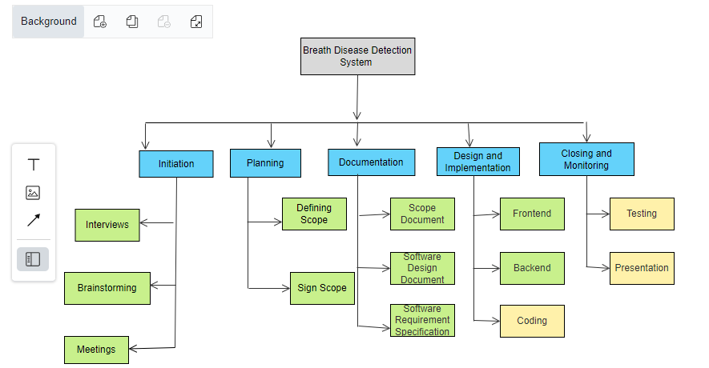

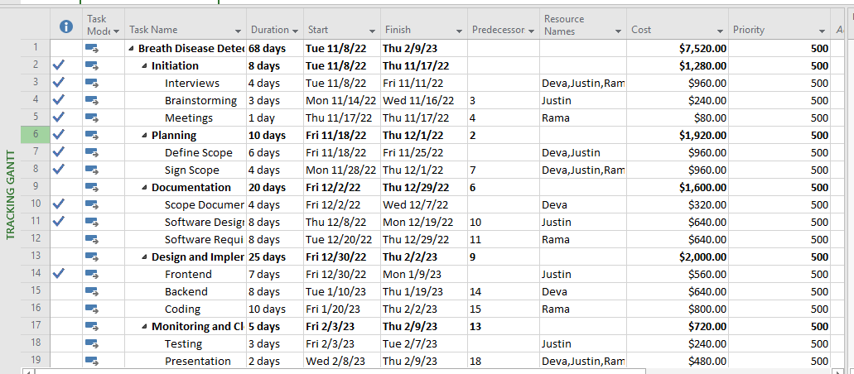

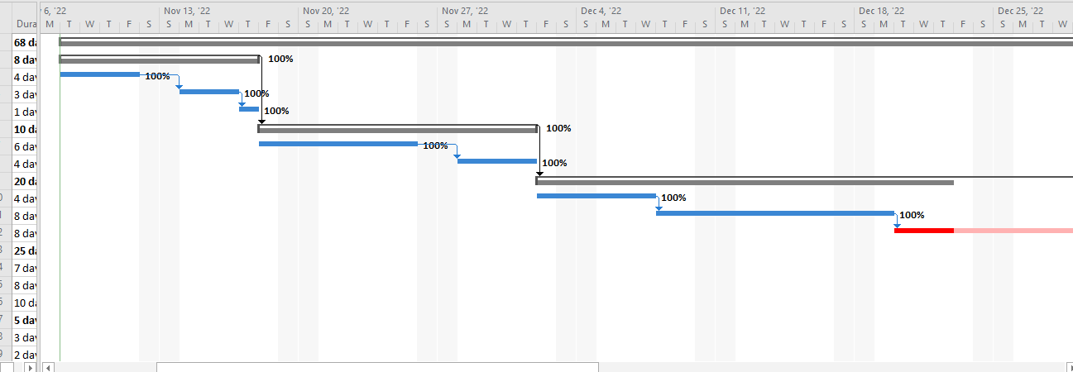

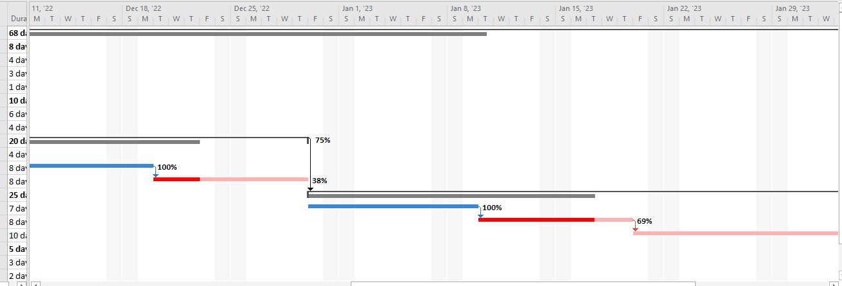

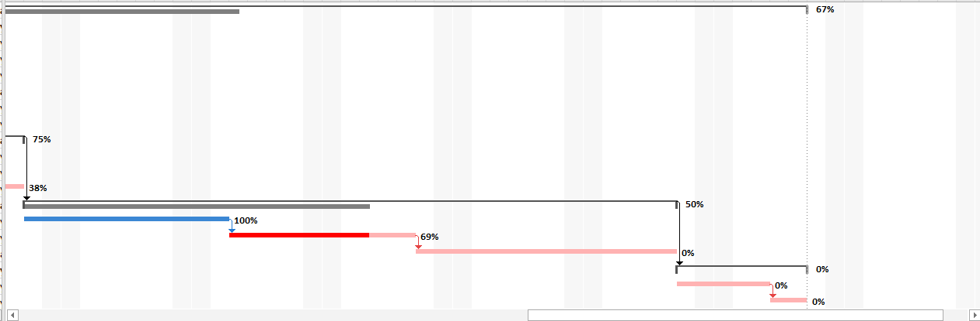

# Mockups

**Appendix A**

**Mockups**

**(NEXT PAGE )**

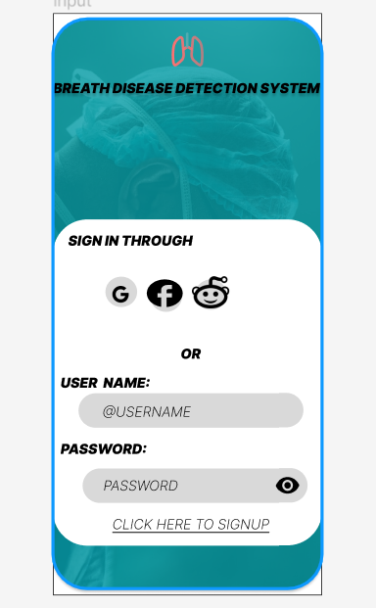

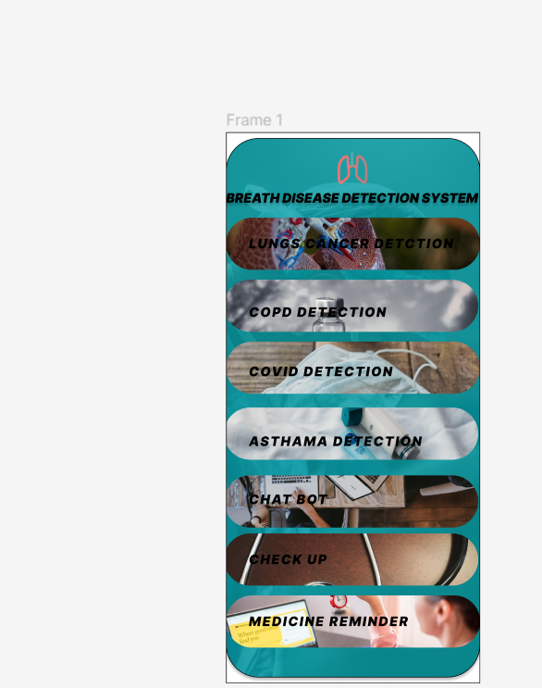

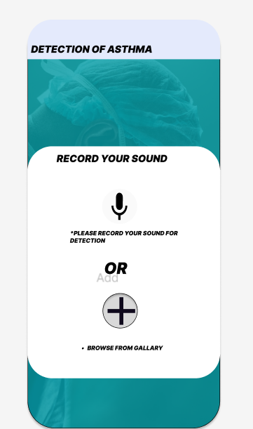

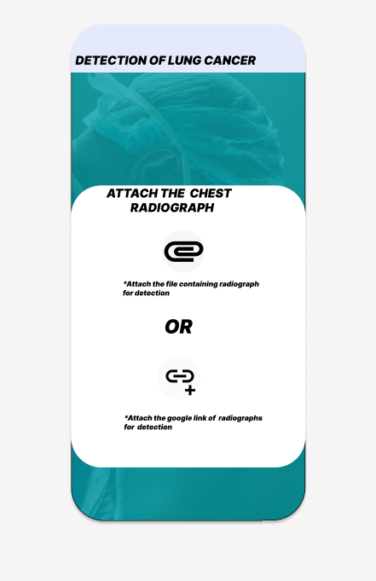

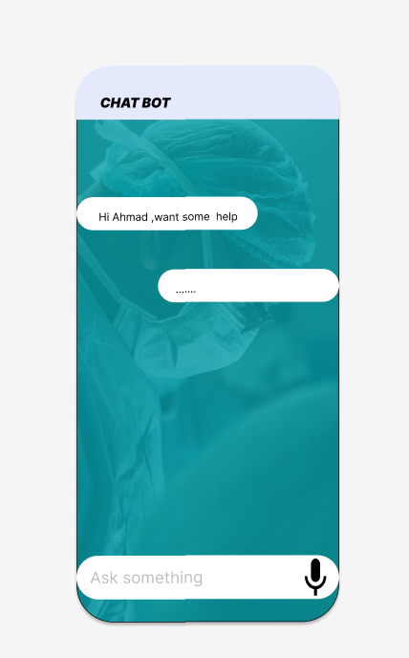

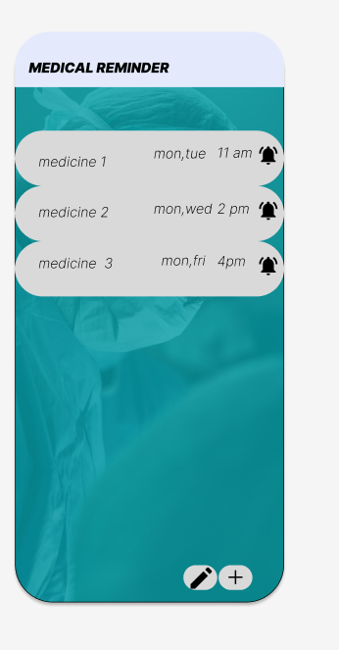

# References

Mention the books, research papers, web links by following given guideline.

I gather the information of Lungs cancer ,COPD ,Covid-19 and Asthma from website

<https://www.woolcock.org.au/asthma-treatment-research>

# Plagiarism Report

Attach the Plagiarism report of your project scope document from library staff of turnitin tool (<http://turnitin.com>)